### ****Q1. Write a query to fetch the EmpFname from the EmployeeInfo table in upper case and use the ALIAS name as EmpName.****

select upper(emp_name) as "EmpName" from employee_info ;

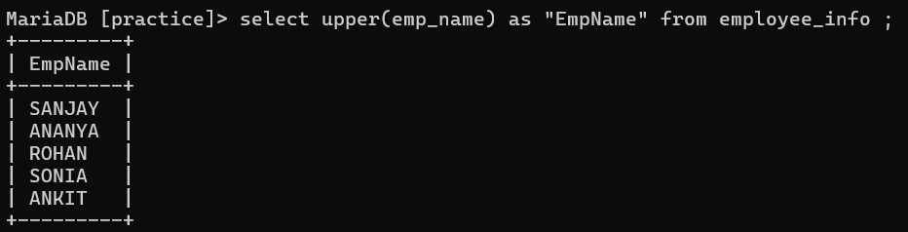

### ****Q2. Write a query to fetch the number of employees working in the department ‘HR’.****

select count(dep) as "HR count" from employee_info where dep="HR";

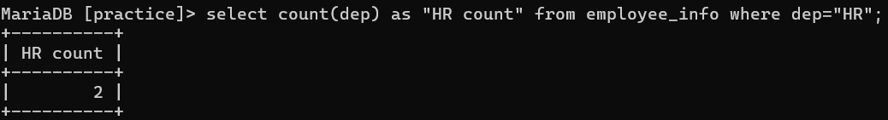

### ****Q3. Write a query to get the current date.****

select curdate();

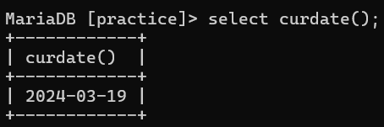

### ****Q4. Write a query to retrieve the first four characters of  EmpLname from the EmployeeInfo table.****

select substring(emp_lname,1,4) from employee_info;

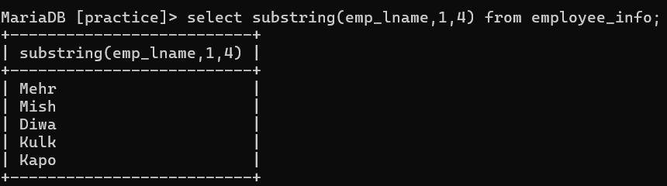

### ****Q5. Write a query to fetch only the place name(string before brackets) from the Address column of EmployeeInfo table.****

create table NewTable as select * from employee_info;

### ****Q6. Write q query to find all the employees whose salary is between 50000 to 100000.****

select * from employee_position where salary between 50000 and 100000;

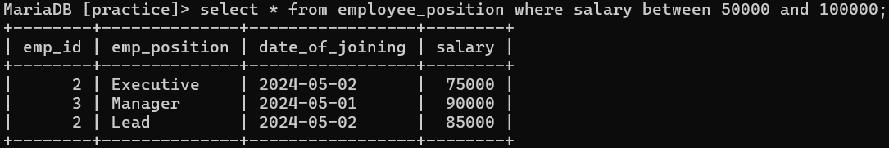

### ****Q7. Write a query to find the names of employees that begin with ‘S’****

select emp_name from employee_info where emp_name like 'S%';

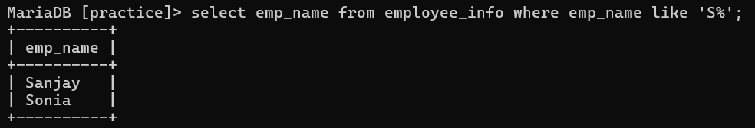

### ****Q8.**** Write a query to fetch top N records.

select * from employee_position order by salary desc limit 1;

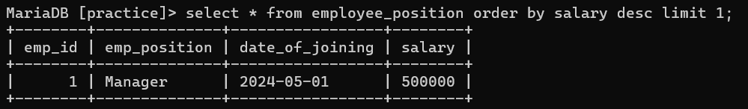

### ****Q9. Write a query to retrieve the EmpFname and EmpLname in a single column as “FullName”. The first name and the last name must be separated with space.****

select concat(emp_name," ", emp_lname) from employee_info;

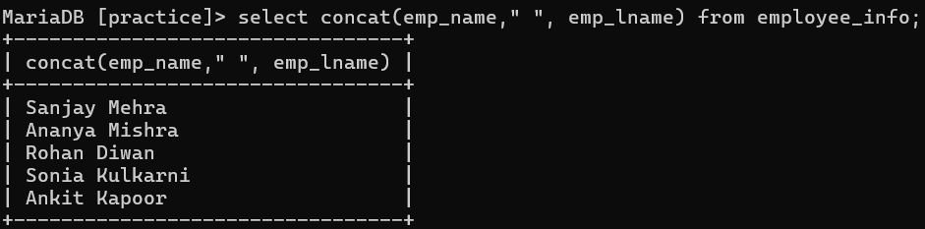

### ****Q10. Write a query find number of employees whose DOB is between 02/05/1970 to 31/12/1975 and are grouped according to gender****

### **select count(*) from employee_info where DOB between '02/05/1970' AND '31/12/1975' group by gender;**

### 

### ****Q11. Write a query to fetch all the records from the EmployeeInfo table ordered by EmpLname in descending order and Department in the ascending order.****

### **select * from employee_info order by emp_lname desc , dep asc;**

### 

### ****Q12. Write a query to fetch details of employees whose EmpLname ends with an alphabet ‘A’ and contains five alphabets.****

### **select * from employee_info where emp_name like '____a';**

### 

### ****Q13. Write a query to fetch details of all employees excluding the employees with first names, “Sanjay” and “Sonia” from the EmployeeInfo table.****

### select * from employee_info where emp_name != "Sanjay" and emp_name != "Sonia";

### ****Q14. Write a query to fetch details of employees with the address as “DELHI(DEL)”.****

### select * from employee_info where address="Delhi";

### 

### ****Q15. Write a query to fetch all employees who also hold the managerial position.****

### select i.emp_id ,i.emp_name, i.emp_lname, p.emp_position

### from employee_info i

### inner join employee_position p

### on i.emp_id = p.emp_id and p.emp_position='Manager';

### 

### ****Q16.**** Write a query to fetch the department-wise count of employees sorted by department’s count in ascending order.

### select dep , count(emp_id) as Employee_dep_count

### from employee_info group by dep

### order by Employee_dep_count asc;

### 

### ****Q17.**** Write a SQL query to retrieve employee details from EmployeeInfo table who have a date of joining in the EmployeePosition table.

### select * from employee_info e

### where exists

### (select * from employee_position p where e.emp_id=p.emp_id);

### 

### ****Q18. Write a query to display the first and the last record from the EmployeeInfo table.****

SELECT * FROM employee_info WHERE emp_id = (SELECT MIN(emp_id) FROM employee_info);

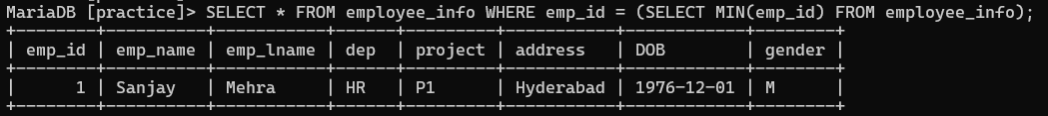

### ****Q19. Write a query to retrieve Departments who have less than 2 employees working in it.****

select dep, count(emp_id) as 'EmpNo' from employee_info GROUP BY dep having count(emp_id) < 2;

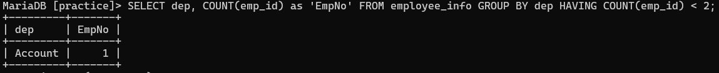

### ****Q20. Write a query to retrieve EmpPostion along with total salaries paid for each of them****

Select emp_position, SUM(Salary) from Employee_position GROUP BY emp_position;

